4-101 AVN REGT

Volume 1, Issue 7 15 MAY 2006

Inside This Issue
Commander Comments
Company Newsletters

News

FROM THE COMMANDER:


Dear Wings Families,

Another month has passed and that flicker you’re beginning to see is the light at the end of the deployment tunnel! It’s been another very busy month for all of Task Force Wings. You might have seen on the news that the Secretary of State and Secretary of Defense visited Iraq. You’ll be very proud to know that once again they were safely moved around Iraq courtesy of your Wings of the Eagle Soldiers. The aircraft and crews were away from Balad for about three days while the mission was ongoing. Never thought I’d say it, but it was nice to get back “home”.
The Chief of the Aviation Branch, BG Sinclair, the Branch Command Sergeant Major, CSM Thomas and the Chief Warrant Officer of the Branch, CW5 Driggers paid us a visit too and if that wasn’t enough the Department of Evaluation and Standardization (DES) visited as well. It was no surprise to me that the staff, aviators and crewmembers made it through all of the visits with flying colors and did exceedingly well with their DES check rides. I am very proud of your Soldiers.
Our new past time is watching the thermometer climb to temperatures over 100 degrees. The maintainers and the crews have not let the heat slow them down. We surpassed 16,000 hours flown and our fuelers are fast approaching 1.5 million gallons pumped in support of rotary wing operations on Balad. That is truly awe inspiring stuff. Remember back at Fort Campbell we typically fly less than 6,000 hours in a year.
Needless-to-say it’s been a very busy month. I am sure it’s been busy for you as well with all the end-of-school activities and Mother’s Day (I hope it was a great one for all of you moms). We could not continue to focus our efforts without your support and love. A heartfelt thank you to the Rear Detachment for all its hard work and the Wings FRG volunteers for all they do everyday. Judy and I recently joined the Company Commanders in thanking the company FRG Leaders with a “Halfway” Celebration—complete with Spa Treatment. On June 1 our Brigade is planning to have an Appreciation Reception for all Volunteers in the Brigade and a luncheon for the leaders. Please know that we do recognize all that you do to make this deployment and our Wings Battalion successful.
Don’t forget Father’s Day is right around the corner…I know I won’t. A reminder to please keep in touch with your Soldiers, it really means more than you can know. While we’re beginning to see that flickering light signaling the end of this deployment, remind your Soldier to remain focused on the mission at hand. It isn’t over yet!

W06

LTC Tony Fish

HAWK ASSAULT!
Dear Hawk Family,
This is both a monthly newsletter and a letter of introduction from myself, CPT John “Steve” Albright. I would like to take the time to tell you a little about myself since, as of 15 APR 06, I’m officially the Company Commander for HHC / 4-101 AVN REGT. I was born into a military family in 1978 and grew up in Virginia, Germany, and Kansas before finally settling down in Augusta, Georgia. After graduating high school there, I attended the United States Military Academy at West Point, NY. Upon commissioning as a Second Lieutenant I moved to Ft. Rucker, AL to attend flight school in 2000-2001. I completed the UH-60 (Blackhawk) Aircraft Qualification Course and PCS’d to Giebelstadt, Germany to join the 12th Aviation Brigade. In MAR ’03-APR ’04 I deployed in support of Operation Iraqi Freedom as a Platoon Leader. I moved back from Germany in DEC ’04 and completed the Aviation Captain’s Career Course before finally arriving at Ft. Campbell in JUL ’05. I have been serving as the Assistant S3 from that point until now. I am very excited to be your loved one’s commanding officer and will do my best to ensure that I am doing everything I can to make the remainder of this difficult deployment as painless as possible.
I am taking command of this company during the difficult 6-8 month mark of the deployment. Historically, this is the most difficult time period during a year long tour of duty. Problems come to a head and the anxiety of impending return increases as the proverbial “light at the end of the tunnel” becomes brighter and brighter. I hope that the level of communication between yourself and your loved ones is increasing during this time instead of decreasing. Instead of ignoring problems, please use the appropriate systems in place to begin to deal with them, so they are not just simmering until they boil over upon redeployment.
On a lighter note, life at LSA Anaconda goes on, with Hawk Assault Soldiers continuing to provide the mission support critical to the 15,000 flight hours flown thus far. This is actually the 20th month I have spent in Iraq in the past 3 years, and the 15th month at Balad Southeast Airbase. The construction continues unabated, with new “mortar-proof” roofs being placed on top of the Post Exchange and Recreation Center. The joke is that we will soon be living better here than soldiers currently do in Korea.
The outdoor pool on the “East Side” of the base has opened 24 hours, providing Hawk Assault Soldiers with the opportunity to cool down and relax a bit during this stressful period.
Congratulations to SPC Shannon on his recent promotion. SPC Shepherd, SPC Scott, and SPC Perkins each reenlisted in their own unique way; with Shepherd standing atop the 8 meter diving platform at the outdoor pool and Scott and Perkins aboard a UH-60 Blackhawk over Baghdad with the Brigade Commander, COL Colt, giving them the reenlistment oath.
CPT John Albright “Hawk 06”
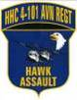
1SG Benny Stephens “Hawk 07”

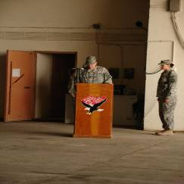

CPT (CH) Grambling says the Invocation for the Change of Command while the BN Adjutant (CPT Adler) looks on.

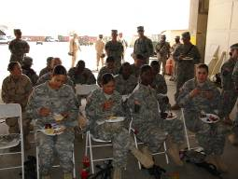
Soldiers from the Supply and S1 Sections enjoy some “Post Change of Command” Snacks.

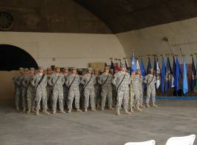

1SG Stephens stands in front of the company formation at the Change of Command Ceremony.

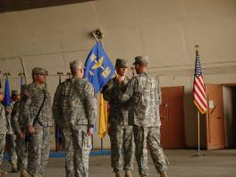

1SG Stephens and CPT Albright look on while CPT Wilson passes the guidon to LTC Fish.
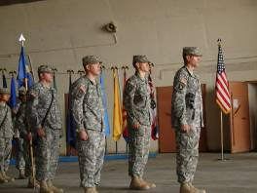

1SG Stephens, CPT Albright, CPT Wilson, and LTC Fish (L to R) prepare to march.
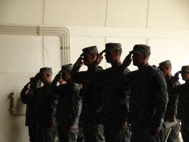

CPT Wilson, LTC Fish, and CPT Albright render a salute to The Colors during The National Anthem.
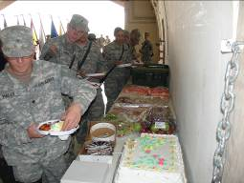
SPC Nally and SPC Siebert check out the spread.

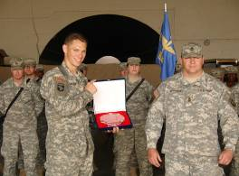

CPT Wilson displays the memento presented to him by the Soldiers of HHC as a token of their appreciation for the previous 11 months of command.
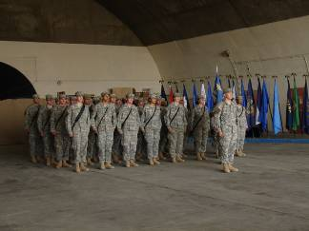

CPT Albright stands in front of HHC / 4-101 AVN REGT.

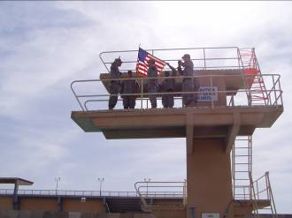
1LT Chappell (L) reenlists SPC Shepherd (in front of the flag) on the 8 meter dive at the “East Side” Outdoor Pool.

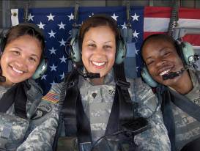
SPC Edwards, SPC Scott, SPC Perkins
Re-enlistment on a Blackhawk helicopter

COMANCHEROS

Greetings to all of the families out there. I hope this news letter finds you all well. May brought us yet again more wild (hot) weather, including numerous dust storms.

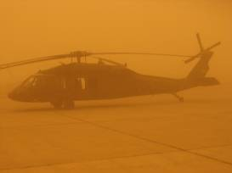
Dust storm at Baghdad International Airport
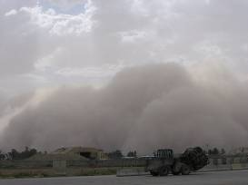
Dust storm rolling-in

On 10MAY we had a company safety day. The morning was fun-filled safety classes and mandatory training. Then in the afternoon we went to the Air Force side of the post where there is a nice pool that the Iraqis used to train for the Olympics. We had a barbecue, and swam, jumped off the high-dive and relaxed. It was the first day since we’ve been here that we had no missions and we were able to just put our feet up. It really built the spirit-de-corps of the unit.
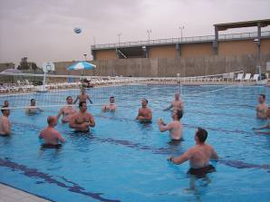
Water-volleyball during Safety-day

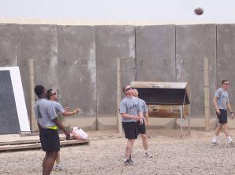
Crockett, Tripp, Gomez, Raglin, and Gorgie playing catch during the safety-day barbecue

We were also visited this month by the Department of Evaluations and Standards (DES). This sort of thing usually doesn’t happen in combat, but somehow we just “lucked-out.” Thanks to our excellent standards sections, headed up by CW4 White, Alpha Company passed the inspection with flying colors. The exact comment from DES to Alpha Company was “you’re right on target.” Congratulations to the standards section.

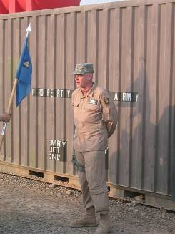

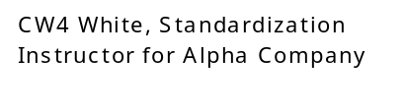
This month, SPC Loren Dougherty pinned on E5 and hence we call him “SGT Dougherty.” He is an outstanding leader of men and will make a huge impact on the future of this company. In the flying news, WO1 Scott Thomas broke his record fourth tail wheel lock pin, which is a record that will not be broken for years to come. On the good news side of the house, Scott has continued to stock the refrigerator with goodies for all of the guys.
SPC Chuck Berry became a flight instructor (FI) in the company. He will be instructing new crewchiefs and gunners on how to properly complete the tasks in the aircraft. Chuck is clearly a leader and will continue to do great things for Army Aviation.

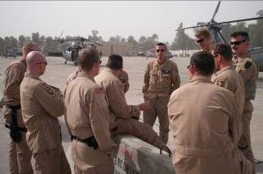
The guys at Washington Helipad.

Our maintenance continues to drive the train here and we have flown a record number of hours here in Iraq. It amazes me the amount of maintenance that the guys perform every night in order to make the aircraft mission capable for the next day. It’s absolutely astonishing and I’m proud of them.
Missions continue to flow down the pipe to us and the guys continue to fly and fly. The weather is getting quite hot. Luckily, the Army has given us the Air Warrior Micro Cooling Garment, which is basically a cooled garment that we wear over our T-shirt. It cools us while we fly. It’s very nice to have that cool garment on while it’s over 100 degrees out. CW2 Carl Snyder has been instrumental ensuring that all of our systems are working, so that your Comanchero stays cool and comfortable in the aircraft.
This month, SPC Russell Bryant accumulated his 500th hour of flight in Iraq this tour, with only 7 months in country. His story is an example of the high amount of flying that this unit is doing. He is leading the company, but others are at his coattails trying to catch up.
As I change command this month, I sincerely thank the spouses, family, and friends of the Comancheros during my time with the Comancheros. The men will be left in the very capable hands of CPT John Wilson, who was the commander of HHC/4-101. It has been a privilege and honor to work with the men from this company. I have no doubts that the Comancheros will continue to do great things, with whatever mission is thrown their way. Again, I want to thank the wives, friends, and the families that we left back home. Your patience, steadfast dedication, and strength back home have made all of the difference. I will not forget all that you have done! Thank you.

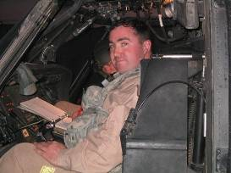
Comanchero 06 signing-off

Sincerely,
CPT Brian K. Ward
1SG Migelangelo Salinas
“Shoot ‘em in the face!”
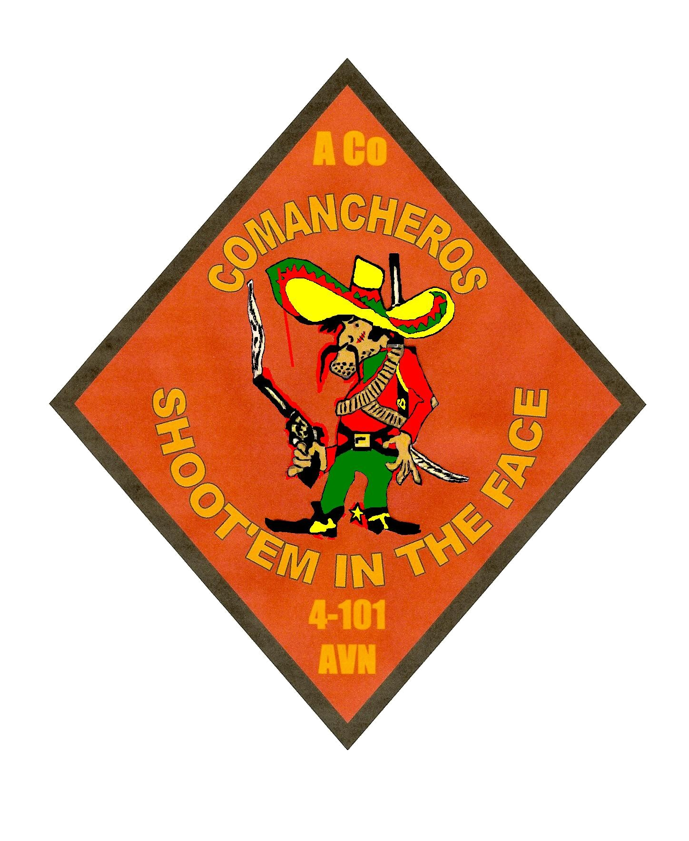

s

Dear Friends and Family of the Kingsmen,
How great it is to be a Kingsmen! The support and love all the families have shown while we’ve been deployed has been outstanding. It amazes me how something as simple as a letter or care package can brighten the worst day of any soldier. Thank you for your continuous thoughts and prayers. They do make a difference and we are fortunate to have you in our lives. We would also like to wish a very happy and special Mother’s Day to all the mothers. Without your love and dedication to our families, our jobs would be much more difficult. We are now into our seventh month and we are starting to see the light at the end of the tunnel.
The last month has been filled with numerous missions of high importance that our company has been selected to support. We were selected by the Battalion to escort the Secretary of Defense, The Honorable Donald Rumsfeld, and the Secretary of State, The Honorable Condoleezza Rice as they conducted meetings with members of the Iraqi government having global implications. This mission gave us the chance to show the high caliber of professionalism that the Kingsmen provide. As some of you may be aware it also gave our aircraft some TV “airtime”, along with one of our crew chiefs who was spotted on Jon Stewart’s “The Daily Show” on Comedy Central for their “moment of Zen” and multiple other, less credible, media outlets.
You may have also read an article about B Company in the Fort Campbell Courier covering the history of the Kingsmen and our current members honoring the members from the past. If you haven’t seen it, you can check it out from the Fort Campbell Courier’s Website: www.fortcampbellcourier.com
Time is literally flying by as we mark off the 7th month and over 4000 flight hours. The Kingsmen eagerly begin our eighth month of this very fast paced deployment. It’s hard to believe that 7 months have already passed, The Kingsmen take it all in stride and they continue to achieve new milestones everyday.
PFC Keiichiro Kizaki, our 19D Scout Door Gunner, has earned his right to proudly wear the coveted Kingsmen patch and being designated a helicopter crewmember with a Readiness Level 1 status. He is doing an outstanding job and we are very happy to have him as a member of this incredible Kingsmen team.
The Kingsmen have recently integrated our newest crew chief SPC Andrew Goens and welcome him to a challenging and rewarding assignment with Bravo Company. He has just completed a two year assignment with the 2nd /501st Aviation Battalion, 1st Armored Division, Hanau Germany. He is 21 years old, single and hails from Anna, Ohio.

Congratulations to Jessica and Raymond Hayes as they began planning for the expected January 2007 arrival of their little “Kingsmen” and new addition to the family, that’s great news.
Again, Happy Mother’s day to all the Kingsmen moms. I assure you the Kingsmen fathers, sons, and daughters miss you very much. We know that difficult times are even tougher to handle when your loved ones are so far away, but we appreciate the class that you handle all of those endeavors and we will be home soon to endure them with you. As you and your family members cope with difficult times, remember that the FRG is always there to help and that you never have to do it alone. Help is always a phone call away.
Please keep The Matthews Family in your thoughts and prayers as they have recently had a close relative pass away. We are thinking about them and sending our blessings as they deal with this difficult time. We would also like to wish all of you who have been dealing with illnesses to get well soon and stay in touch with the FRG for support.
As always, we are thinking of you and miss you very much. Keep us in your thoughts and prayers; honor us by living in peace, and we will continue to serve with pride and distinction
Sincerely, CPT Mike “Jethro” Stull

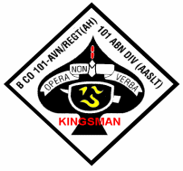
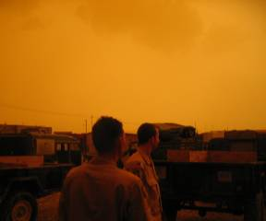
Dust storm in Iraq

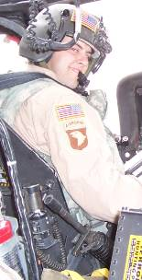

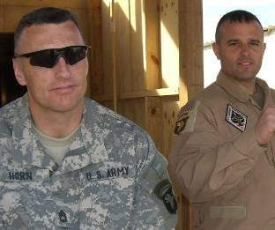

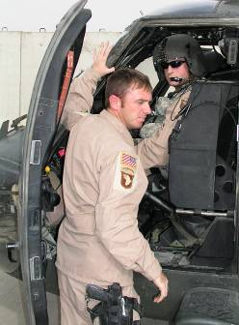

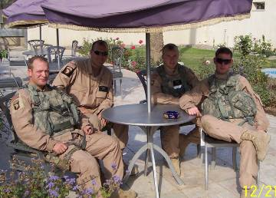

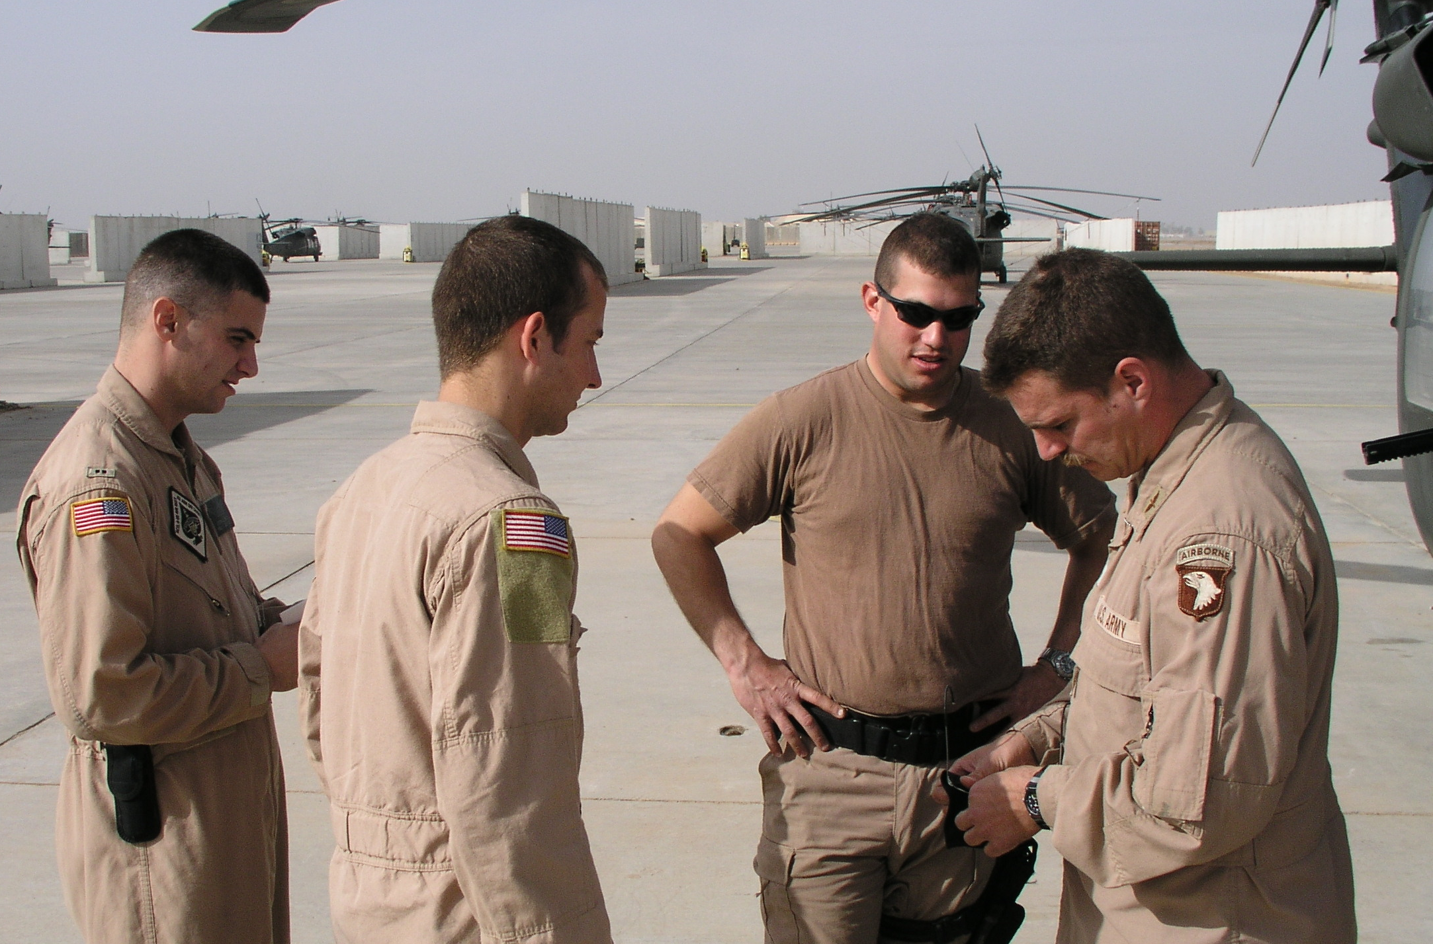

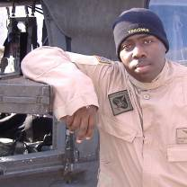



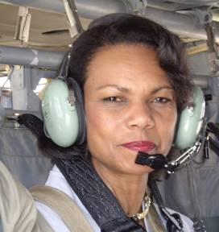
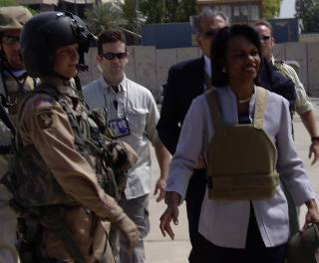

Blackwidows

Let me start this off by saying that the rainy season has officially ended but yet the rain has not stopped. We have had numerous thunder-storms and rain showers since last month’s letter. I personally hold CW3 Hummingbird responsible for working behind my back. This month we had several interesting and notable events happen.


This is a picture from the C CO CP of one of the storms that rolled through. It brought lots of hail and the orange color is actually dust.

We would like to welcome Specialist Clark. He is joining us from our very own Delta Company. He worked down there for over a year learning the airframe and maintenance. We are looking forward to getting him up and flying with us soon.
We had several Soldiers get the opportunity to meet country music legend Charlie Daniels. The Soldiers were shutdown and having lunch while carrying several generals. As the story goes, the Soldiers were having lunch at the embassy dining

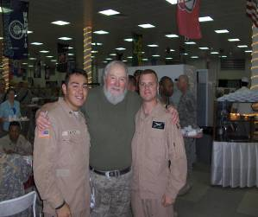
Specialist Nichols and Corporal Garvey with Charlie Daniels.

facility and Charlie Daniels just walked up to them. After introducing themselves, SPC Nichols tasked Brigadier General Frutiger (G1, United States Army Europe and 7th Army) to take his and CPL Garvey’s picture with the singer. Now I am a bit rough on the rank structure but generally orders come from the top down. None-the-less the general obliged them and took the picture.
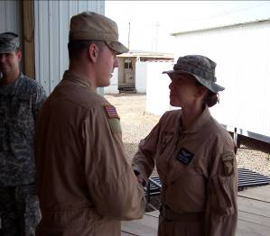
Specialist Bown being promoted to Sergeant by Staff Sergeant Day.

This month we had the privilege of promoting Specialist Bown to Sergeant Bown. After the ceremony the company gathered around to congratulate her and move into the Cactus lounge for refreshments.
Also this past month Charlie Company had the honor of supporting a mission carrying The Honorable Secretary of Defense Donald Rumsfeld.
And last of all I would like to take this moment to wish all of the mothers in the Blackwidow family a Happy Mothers Day!

CPT Brian G. Wood, CDR
SFC Scott Brown, 1SG

Charlie Co
4-101
AVN

DESPERADOS
The month of May meant one thing: the heat is on. The forecast for the 14th of May was set at over one hundred degrees, and the previous weeks gave some hint of the climate change to come. The Soldiers of Delta Company have kept high spirits, though, as we prepare for the summer months. Work shifts change, duty days become modified depending on the mission, and the most important thing on everyone's mind gives great comfort - Balad has two swimming pools.
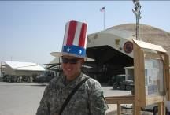

There were some very happy events for Delta Company over the last several weeks. Sergeant Tanudjaja became a United States Citizen on May 12th, taking the oath of fidelity with more than a hundred other candidates for naturalization in a patriotic ceremony at the post theater. Hatt and Phifer decided to try their hand at something new and are currently training to become door gunners. They have enjoyed their training immensely and look forward to seeing more of the country of Iraq during their flights.
SGT Bridgeman continues to flex his artistic muscles, shedding the tough-guy image and picking up a paintbrush to continue his beautification of the face of the HAS. His current project - an eagle - took shape nicely, though he continues to attempt to hide this more sensitive side of his nature.

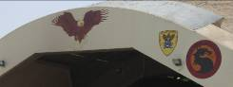

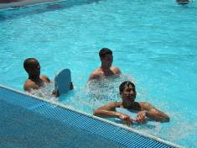

Two new avionics Soldiers were welcomed to the company: PFC Gallagher and PFC Murphy – a valued addition to the shop. The Avionics Shop performed very well during a pre-ARMS inspection this month, a testament to the hard work and dedication of the Shops Platoon. Sheet Metal built what many come to be affectionately referred to as the "tree house", an immense structure inside the HAS sheet metal shop where they hide from their superiors. Shortly after its discovery, First Sergeant Paul gave up, as can be seen in this picture. For this reason, Sergeant First Class Mihalko will be the acting First Sergeant while 1SG Paul takes some well earned leave. It was hard to finally convince Top to take some leave, but after reaching the breaking point we all felt it was in the company's best interest to give him some time off. SFC Mihalko, knowing that he has to assume 1SG Paul's responsibilities, has decided that he needs a little more energy. He has therefore begun a 30,000 calorie a day diet! Bowe and Garcia attended Duty Day with God, an opportunity to leave Anaconda and tour Baghdad. They had a wonderful time, and once again we are in debt to Chaplain Gramling. The sheet metal shop also constructed a grill out of spare parts from the local junk yard, and Phillips can be seen here grilling something that might be pigeons. Delta Company also got a new cement pad installed for use as a helicopter wash rack. It’s getting plenty of use and is a nice addition to our maintenance support operations.

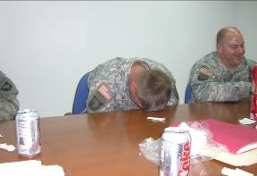
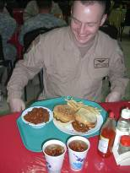

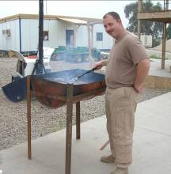

We would also like to extend our continued thanks to the hard work of the FRG and Rear Detachment, keeping Delta Company's soldiers fighting strong. Without the tireless support of the families back home, it would be much harder for our men and women to continue with the vigor and determination that they display on a constant basis. Thank you and we will see you soon.

‘Til next month,

“Fix ‘em or Die!”
CPT Rachelle Hathaway
1SG David Paul

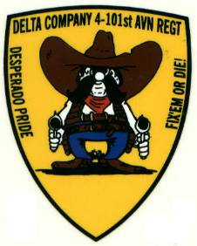

Foward Support Company

Commander’s Corner
I hope this month’s newsletter finds you all in good heath and spirits. I know my spirits are high as I can finally begin to see the light at the end of the tunnel. Can you believe we have been deployed for seven months? I can’t. But it is very exciting. Only five more months to go! The month of May has been as action packed as the previous months for all of the Workhorse Soldiers. From volleyball tournaments, promotions, reenlistments, and doing our every day jobs we have kept pretty busy this month. We are really starting to feel the heat now that we are getting closer to the summer months. Drink water is becoming the favorite saying for all the leaders over here. As the months pass, I continue to be more and more impressed with the quality of Soldiers I am luck to have in this Company. Your family members, my Soldiers, are truly the best the Army has to offer and I am very lucky to command them. I also deeply appreciate the sacrifices that all family members are making during this extremely tough time. Keep your focus, and it will all be over very soon.
As always, there is a lot of good news to pass along for this month. First off, I would like to congratulate POL platoon for winning the Commander’s Cup for a second consecutive month. So far, they have been the sole owners of the Cup. However, I am confident that they will be defeated soon. I would also like to congratulate 1LT Alcaria, SSG Howard, SGT Abreu, SPC Pender, and SPC Grome on their promotions. They are all highly deserving individuals. And finally, congratulations go out to both SSG Howard and SPC Benton for their reenlistments this month. The Army is lucky to have both of them. Again, thanks to all the Workhorse family members. We all greatly appreciate your support and eagerly await the day we will be reunited.

First Sergeant’s Corner
I would like to say hello to all of the Workhorse families and friends and thank you all for the support of your soldiers. We welcomed two new soldiers to Iraq, SPC Benton (88M) and PFC Sandefur (63B). Congratulations to SPC Benton for re-enlisting six days after arriving in Iraq, the tax free benefit will come in handy for his family. I would also like to congratulate all the soldiers that received awards and got promotions on the 1st of May, well deserved and more to come. It’s not hit the triple digits yet and the sandstorms are a sight to see. Stay hydrated, keep plenty of sunscreen and your sunglasses on hand, “Hard as Hooves”

Promotions and Awards
Congratulations to 2LT Alcaria (POL) on his promotion to 1LT on 30 April. Congratulations also to SGT Howard (MP) on his promotion to SSG, SPC Abreu (Distro) on his promotion to SGT, and to PFC Grome (POL) on his promotion to SPC on 1 May. Good Conduct Medals were given out to SGT Abreu (Distro), SPC Mercado (MP), SPC Edmond (POL) and SPC Barnes (POL) this month. SPC Edmond and PFC Hamilton (Distro) received Certificates of Achievement for their selections as Battalion Soldiers of the Month, and SPC Abreu and PFC Paulk (Distro) received safety awards for placing second (by 1 point) in the driver’s rodeo. Congratulations to all.

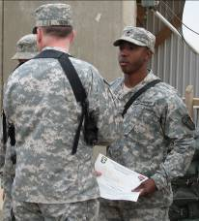

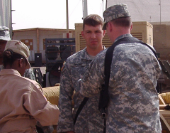

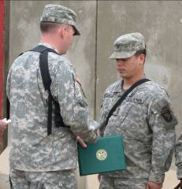

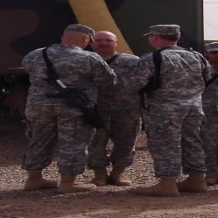
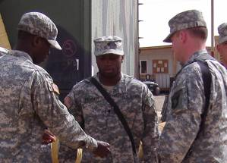

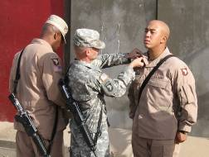

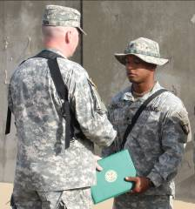

Re-enlistments

Congratulations to SPC Edmond who re-enlisted with COL Colt and all the other 159th CAB soldiers who re-enlisted while deployed. SPC Edmond was the 303rd Brigade soldier to re-enlist in Iraq. SSG Howard is re-enlisted by CW2 Minster. Congradulations. You’re well on your way to fullfilling your dream. Keep up the good work. 1LT Ghazal re-enlists SGT Reed. Good job and Congradulations. You’re service is invaluable to the Company. SPC Benton re-enlists with 1LT Gray only days after joining the unit. Welcome to our family.
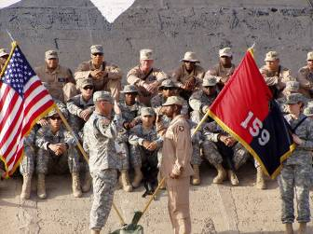
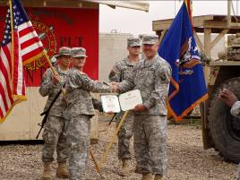
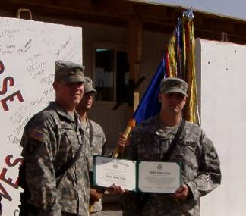

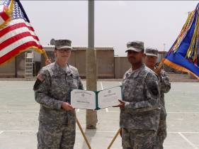

Soldiers’ Corner
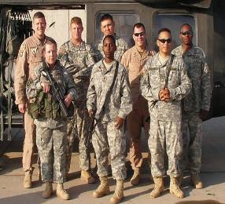
Tolbertson (MP) and Blann (MP) and Maldonado (Distro) all pose for the photo op in front of the Blackhawk, their taxi to Baghdad.

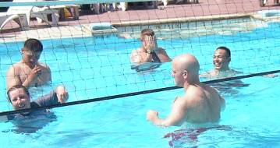
Here are the guys again, playing some volleyball in the pool, possibly training up for the company competition. We wonder if Blann is hiding his face because they were losing….
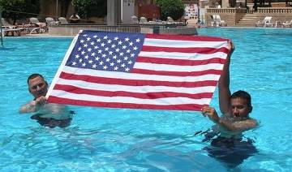
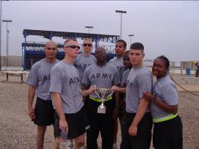
SPC Morales and PFC Run (Distro) show their true colors.

Respectfully,
Jason E. Ison
“Strong Families make Strong
Soldiers!”



RENEGADES
The company would like to wish a very special Mothers Day to not only our mothers, but to all our wives at home taking care of the kids while we are gone. None of us take for granted the job you have to do while we are gone and we all appreciate your hard work, sacrifices, and understanding while we are deployed. I think a lot of the guys owe some spouses a night out for a nice dinner and relaxing evening (at a minimum). Again, Happy Mothers Day to you all!

Soldiers’ going home on leave continues as it will through August. It is typically taking 2-3 days of travel to go from Balad to Kentucky but well worth the trip. Everyone so far has had a great time while on leave which is great news. The guys are all working very hard here, and with the heat, the constant flying of missions and the amount of time we have been gone, you would expect much worst attitudes. Not the case though, this is a great group that although they all miss home, remain mission focused and continue doing their jobs and do them well.


Angie, Anna Claire and Porter Whitney home from the hospital.


Chloe Isabella Grace Stevens, daughter of Jay and Tiffany Stevens.

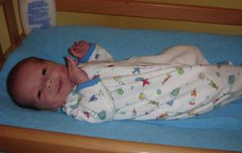
Hunter Foster, son of Scott and Mary Foster.

As of May 20, the unit will have been in the Iraqi theater of operations for six months. We are at the half way point, so it is all down hill from here. After our year here in Iraq, we will return to Ft. Dix, NJ for our demobilization period of approximately six days. Once we have more details, we will provide those to you all. After our demobilization we will be returning back to Frankfort for a well deserved homecoming. Just so you all know, the unit will not have to have weekend drill the first two months we are back so we can devote more time at home to our loved ones.

Meet the Company

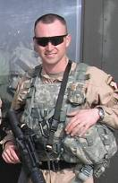
CW2 Daric Scheiderer
Pilot
Wife: Ashley Erin
Children: None yet
Home: Georgetown, KY
Age: 28
Occupation: Pilot with RAID (Reconnaissance and Interdiction Detachment)
Company: KY Army National Guard
Years in the Military: 10
What he misses most (besides his family): Motorcycle tours of KY with wife and friends.

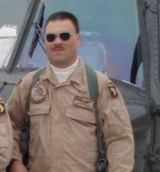
SGT Tom Simpson
Crew Chief
Wife: Cassandra
Children: Ryan and Kaitlyn
Home: Lexington, KY
Age: 37
Occupation: Engineer at L-3.
Company: L-3 Communications
Years in the Military: 9
What he misses most (besides his family): The SCI FI network and working with his son and the rest of the Cub Scout Den.

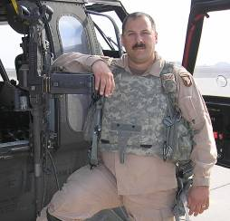
SGT Curt Kaiser

Crew Chief
Wife: Brenda
Children: Devonah, Kyle and Alexandra
Home: Columbus, OH
Age: 39
Occupation: Firefighter / EMT
Company: Columbus Fire Department
Years in the Military: 20
What he misses most (besides his family:
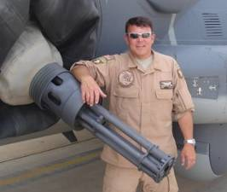
CW2 Phillip “PJ” Pittman
Maintenance Test Pilot
Wife: Kimberly
Children: Hudson
Home: Salvisa, KY
Age: 33
Occupation: Technician
Company: AASF
Years in the Military: 8
What he misses most (besides his family):What PJ misses most besides his beautiful wife and amazing daughter is “common sense”, and a good rock n’ roll song while driving on some back country road on a cool morning in Kentucky.

Aircraft 26850

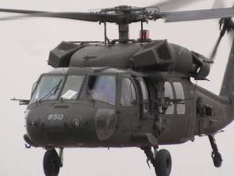

Aircraft Tail Number: 26850
Nickname: Lois
Year of Manufacture: 2000
Current hours: 1200.4
Assigned CE: SGT Chris Morris

850’s full time crew chief back in Frankfort is SGT Will Pope. He nicknamed her Lois after Superman’s love interest, Lois Lane. Since SGT Morris is now responsible for her, the only “L” he could come up with is Lynn, his wife’s middle name.

850 has been struck twice by lightning, both times while parked at Frankfort. Although all the damaged components have been replaced, ghosts of stray electricity show every now and then.

Battle Rostered Crew that flew her into Iraq:
CW3 Stephen Hunnicutt
CPT Mark Brozak
SGT Chris Morris
SPC Jeremy Knight

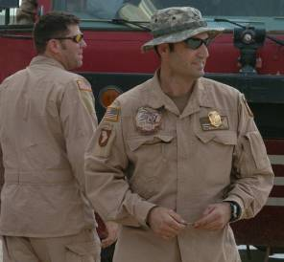
Newly promoted Fire Department Lieutenant Roger Smith.

The company recently had the opportunity to promote SFC Smith to Lieutenant in the Lexington Fire Department, Engine 6. We were able to enlist the help of the LSA Anaconda Fire Fighting Company to come down to the flight line for the festivities as well as most of the company and several soldiers from the Battalion, including LTC Fish and CSM Sowers, our BN Commander and Command Sergeant Major.


A poem written by Mrs. Maureen Pylant of Sherwood, Arkansas to her husband, CW3 Barry Pylant who deployed with us. Barry was able to convince her to let us print it and I think you will all like it.

The morning is crisp in our hometown so small
But once again I wake with no one to call.
My love and my life are so far away,
When will we be the same-it’s so hard to say.

While I stay home and drive to and fro;
He flies, taking care with precious cargo.
I am charged with our home and our daily thing;
He is charged with missions to make freedom ring.

My husband the pilot makes those rotors turn fast;
He secures others’ homes to insure safety will last.
He sleeps to strange noises all around it would seem;
He awakes to help accomplish a dream.

Our lives are so different and yet still the same;
We continue on with no fortune or fame.
My husband so absent but still next to me,
For I never will leave, doesn’t anyone see.

I am proud – so proud I could shout;
Let everyone know what he’s all about.
The sacrifice he makes for our little girl,
So far away for another with curls.

Dreams you see happen no matter what.
Freedom and safety are always bought,
With blood and sweat so far away;
So that little girl will be heard some day.

My love and my husband please know this,
Each night I send you a sweet loving kiss.
I know you can’t feel it from where you are,
But please know in my dreams I am never too far.

My thoughts and my prayers go up every day,
So God will keep you safe, no matter the way.
I need you back, safe and sound with me here;
Your love I hold so precious and dear.

I know your life is so hard for a time,
This I promise to you in this rhyme.
My love and my life you always will be,
To my heart, only you hold the key.

Maureen Pylant

CPT Mark Brozak
Renegade 06
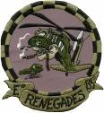

PATHFINDERS
Pathfinder Family and Friends,

This past month has flown by, and we are now one more month closer to coming home. We have begun our redeployment planning, and I promise you, as soon as we get it flushed out, I will be passing along more information. We have begun to award medals and badges to our very deserving Soldiers. Brigadier General Rife presented four members from Team 3 the Combat Infantryman's Badge up in Mosul. Congratulations to SFC Snyder, SSG Agent, SPC Burbridge, and PFC O'Connor. They are very deserving of this distinction. We will be holding more awards ceremonies in the near future.
I send a very special thanks to all of the FRG volunteers. You have made this deployment so much easier on us, and I am very appreciative. I know you are all very busy with your families, so I thank you for your time and energy as POCs, newsletter writers, FRG leader, and all the rest. Thank you very much.

Take care and we will be home soon enough!

CPT Mike Wiser
Ranger 06

Rear D

Wings of the Eagle Soldiers, Families, and Friends,
Another month has come and passed. I would like to extend a heartfelt Happy Mother’s Day to all the mothers out there. I know life is going to be hectic as school lets out for the summer.
Rear Detachment operations keep going strong. We continue to receive new Soldiers in all of the time. They continue to spend a few weeks at Fort Campbell getting settled in before heading over to the desert to support the mission and their fellow Soldiers who are already deployed.
Last week I inventoried the furniture in the new Pathfinder barracks rooms. The renovation looks good and I think really improved the standard of living for our Soldiers in those barracks. It is amazing what a fresh coat of paint and a little TLC can do to a building.
As always, the Rear Detachment is here to support the families in the Rear. If anyone has any questions or needs support in any way do not hesitate to contact me. If anyone has lost the number over the months my office number is (270) 798-6601.

CPT Mike Clark Rear 06
SFC JT Williamson Rear 07

Even with all the hard work, your FRG volunteers still manage time for fun. Recently we joined some folks from our sister battalions and HHC Brigade to “train” on different with weapons.

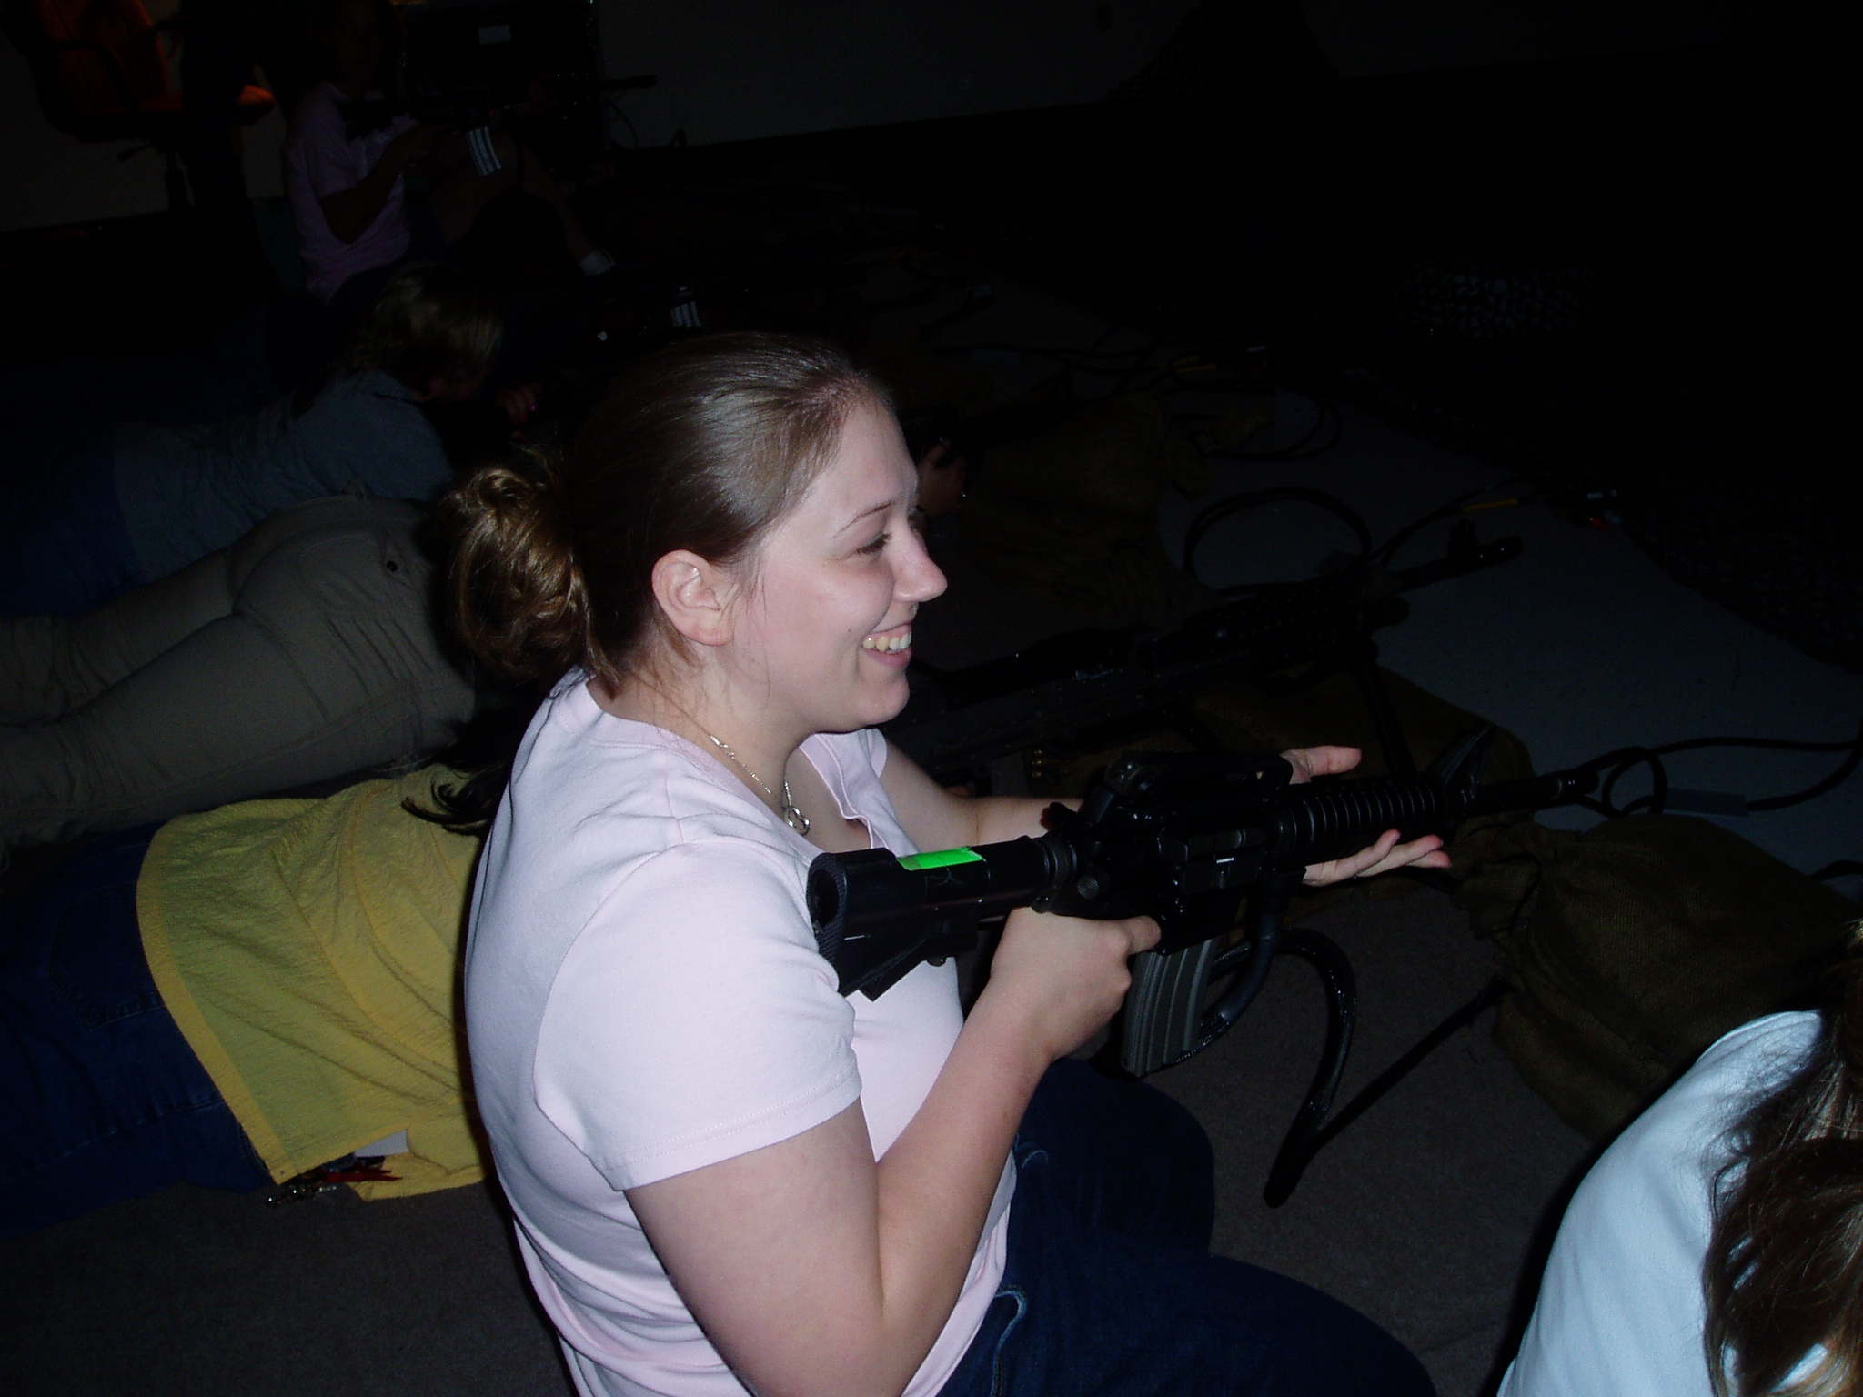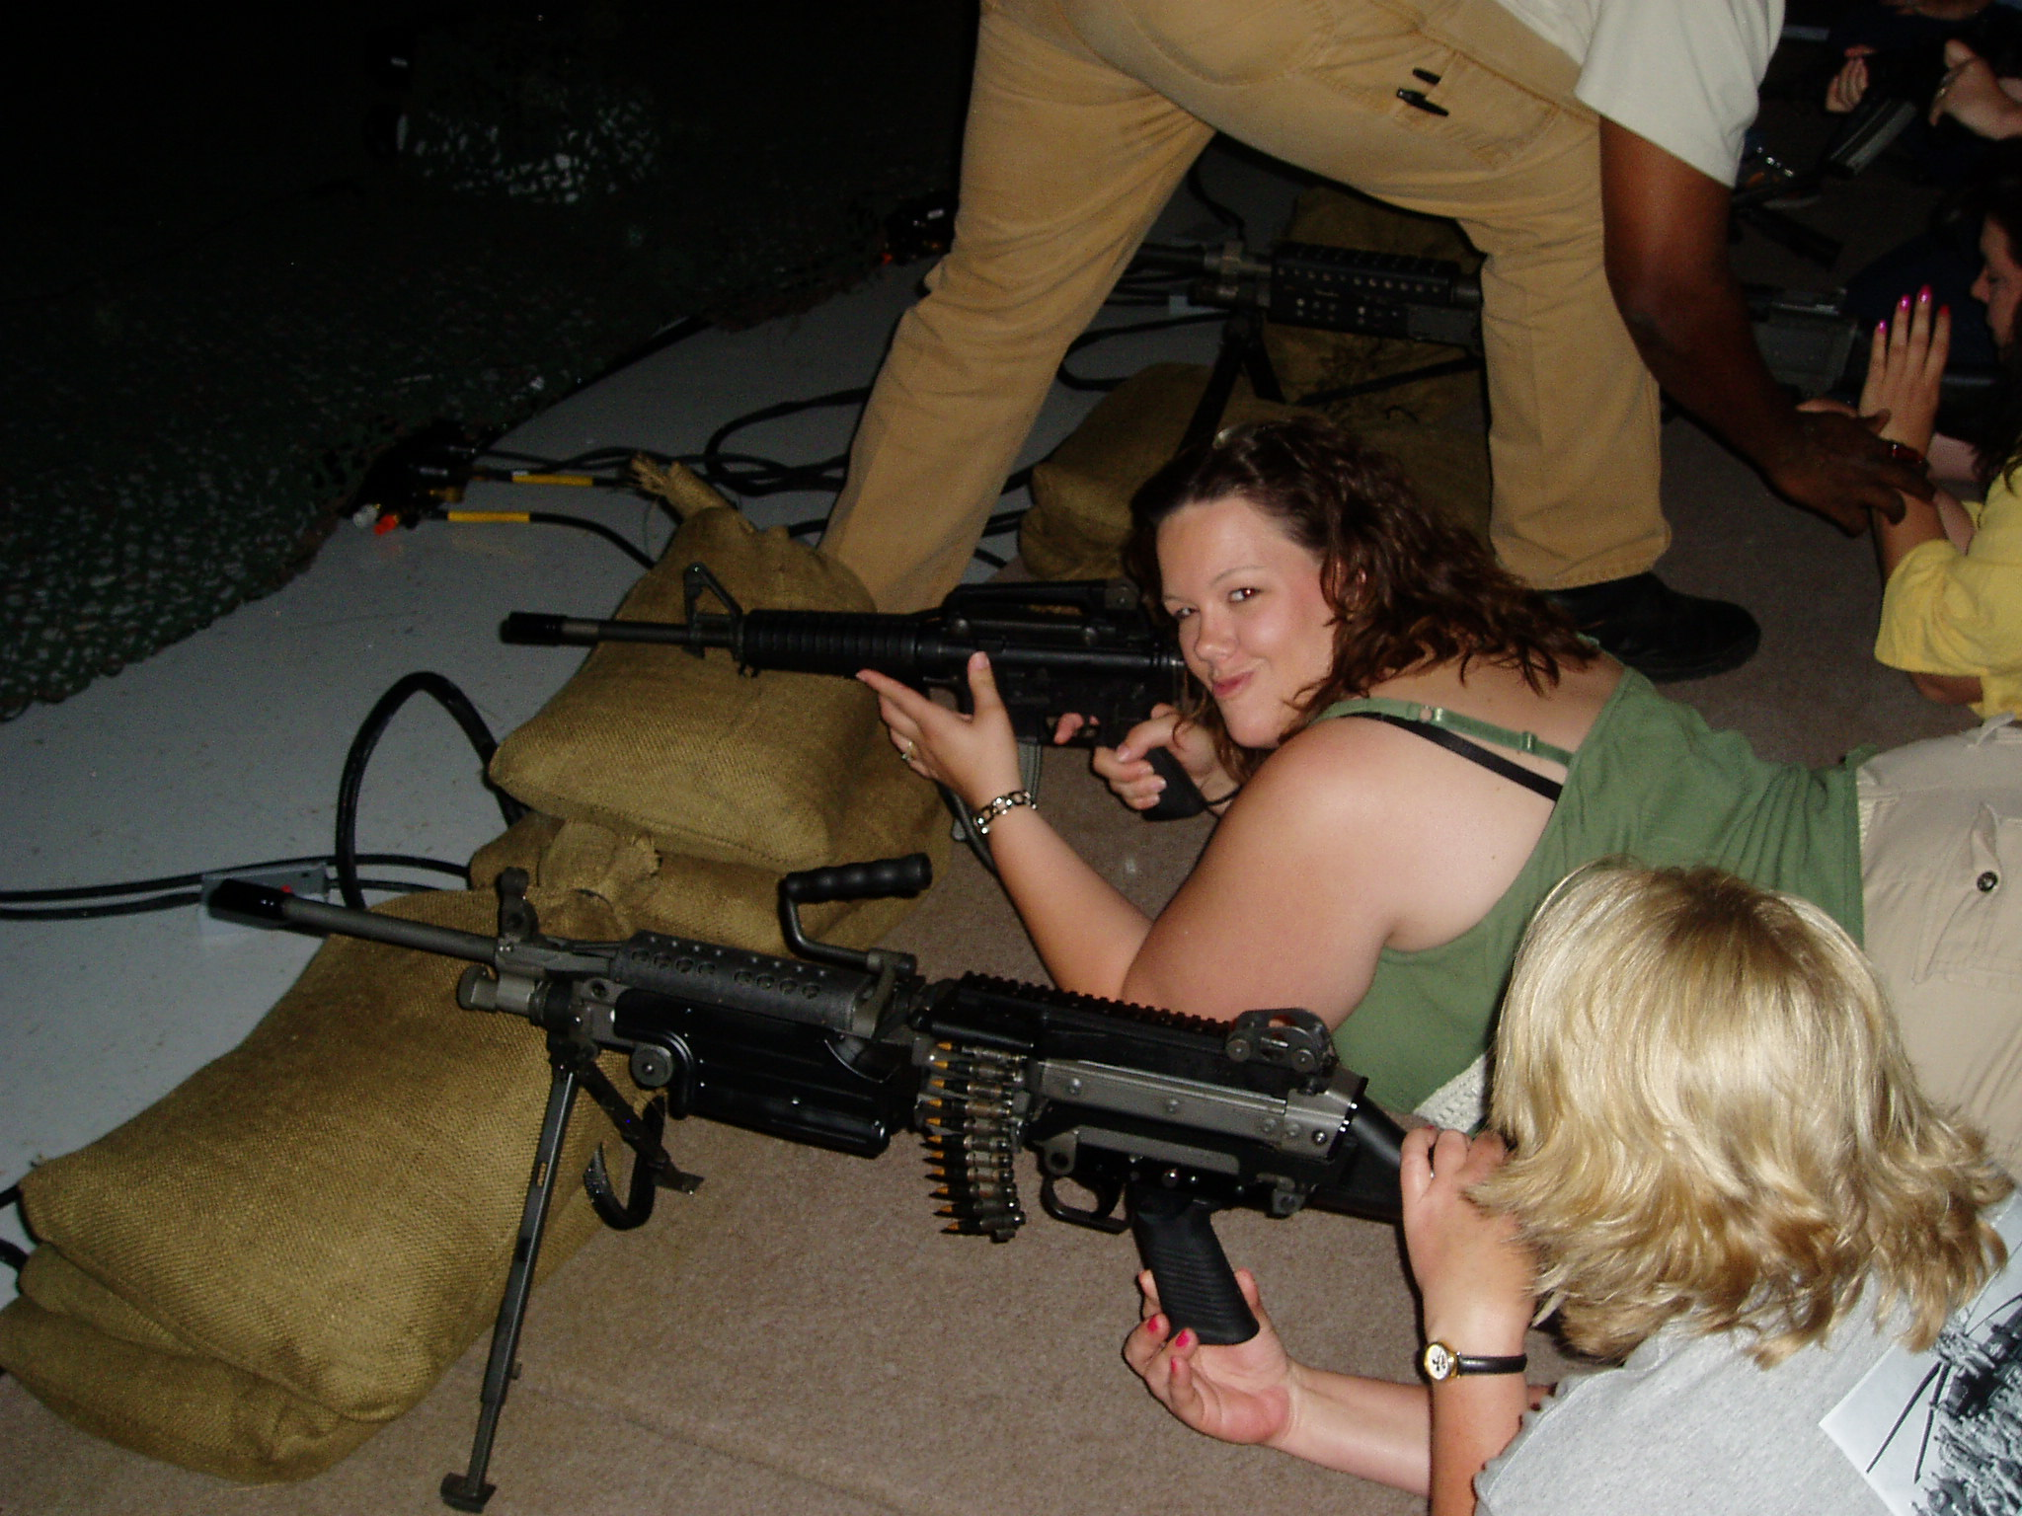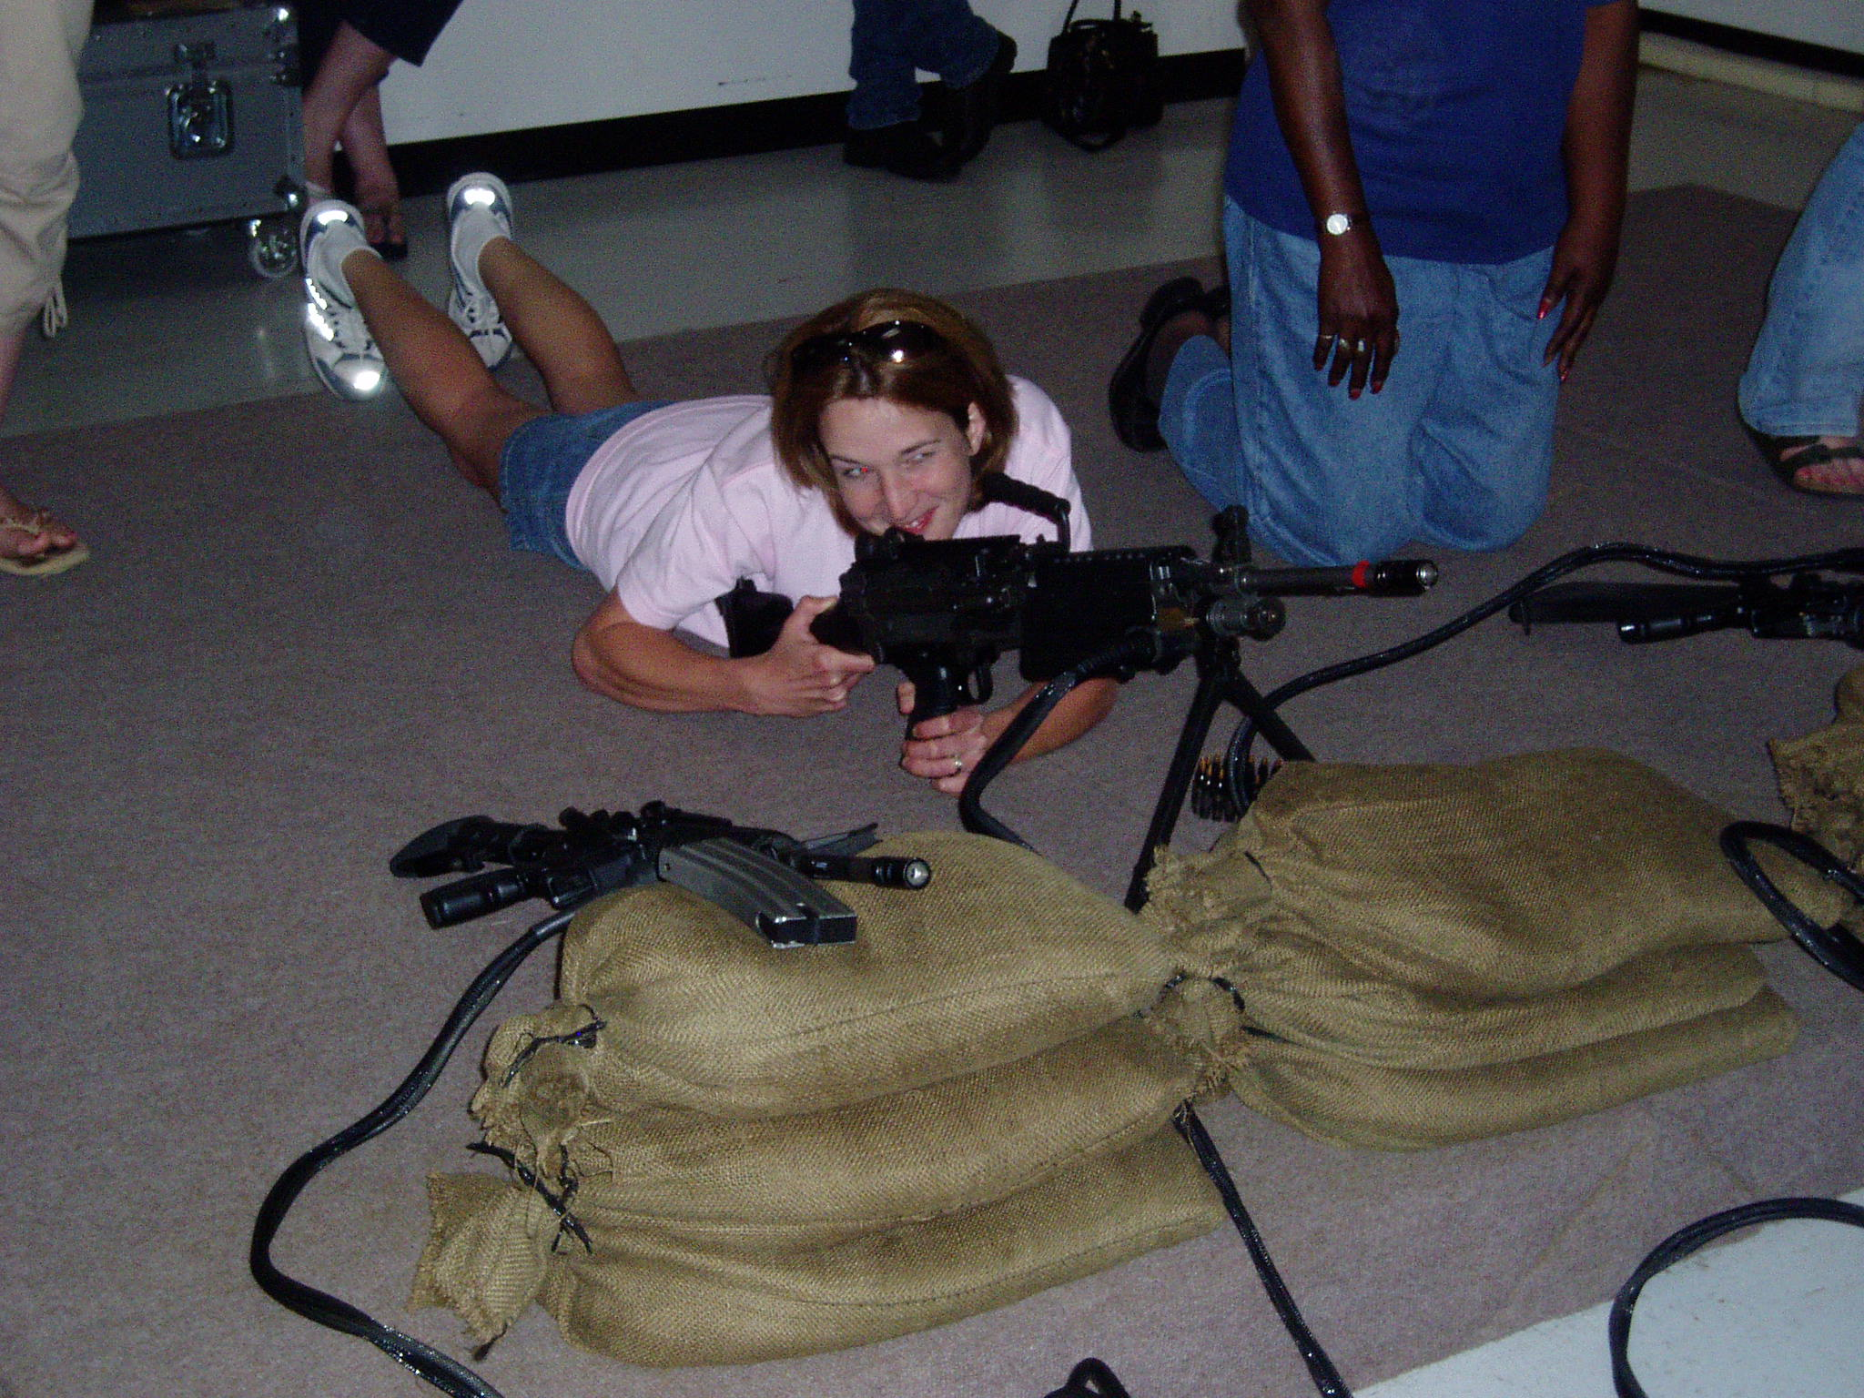
Some in our group were amazingly good—well…relatively speaking! Melissa Hudson was our best shooter…I am certain I was the worst! It was a great time and gave us a whole new appreciation for all that our soldiers do to train. The weapons were heavy just to hold!

Thank you for all each of you does to make the Wings Battalion so much fun!
XO
Judy Fish



